CHAPTER 0 – INTRODUCTION
HTML, which stands for "HyperText Markup Language," is the foundational language of the web. It's used to create and structure websites. By utilizing HTML tags, we can define the appearance and layout of a website. With a good grasp of these tags and their proper usage, creating beautiful websites becomes straightforward and efficient!
THEN WHY CSS & JAVASCRIPT
HTML is used to define the layout of a page, providing a barebone structure for the content. CSS is used to add styling to that barebone page created using HTML. JavaScript is used to program logic for the page layout e.g. What happens when a user hovers on a text, when to hide or show elements etc.
A BEAUTIFUL ANALOGY
• HTML = Car body (only metal)
• CSS = Car paint, decoration etc.
• JavaScript = Car engine + Interior logic
We will start learning how to build beautiful websites in this course.
INSTALLING VS CODE
We can use any text editor of our choice. Here I am using VS Code because it is lightweight, opensource & from Microsoft. Note: You can write HTML even in Notepad. Text editors like VS Code just makes these things easier.

CHAPTER 1 – CREATING OUR FIRST WEBSITE
We start building a website by creating a file named index.html. index.html is a special filename which is presented when the website root address is typed.
A BASIC HTML PAGE
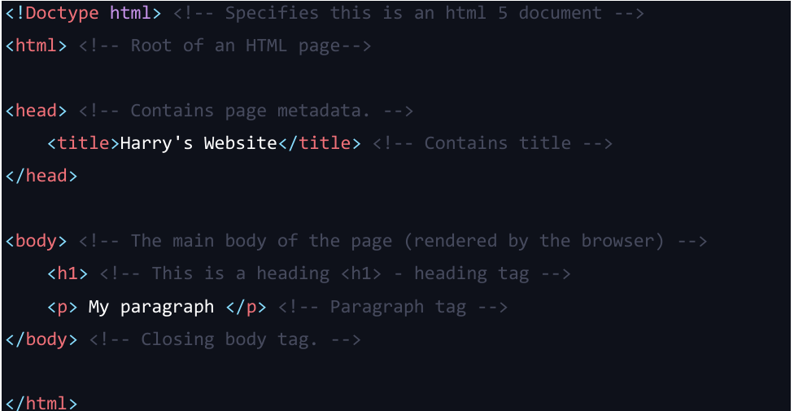
A tag is like a container for either content or other HTML tags.
Text Editor Web Browser Output
IMPORTANT NOTES
• <head> and <body> tags are children of HTML tag.
• HTML is the parent of <head> & <body tags>.
• Most of the HTML elements have opening & closing tag with content in between opening & closing tags.
• Some HTML tags have no content. These are called Empty elements e.g.
• We can either use .htm or .html extension.
• you can use “inspect element” or “view page source” option from Chrome to look into a website’s HTML Code.
HTML element = start tag + content + end tag
COMMENTS IN HTML
Comments in HTML are used to mark text which should not be parsed. They can help document the source code.
<!-- This is a single-line comment -->
<!--
This is a multi-line comment.
It spans multiple lines. -->
CASE SENSITIVITY
HTML is a case insensitive language. <H1> and <h1> tags are the same.

CHAPTER 2 – BASIC HTML TAGS
We can add elements inside the body tag to define the page layout.
HTML ELEMENT
An HTML element consists of everything from the starting tag to the ending tag.
<body> <!-- Opening tag -->
Content
</body> <!-- Closing tag -->
HTML ATTRIBUTES
HTML attributes are used to add more information corresponding to an HTML tag.
<html lang="en">
Example:
<a href= "https://codewithharry.com"/> Harry </a>
We can either use single or double quotes in attributes.
THE HEADING TAG
Heading tag is used to mark headings in HTML. From h1 to h6, we have tags for the most important to the least important heading.
<h1> Most important heading </h1>
<h2> Another heading H2 </h2>
<h3> Another heading H3 </h3>
<h4> Another heading H4 </h4>
<h5> Another heading H5 </h5>
<h6> Another heading H6 </h6>
Note: We should not use HTML headings to make text thick or bold.
THE PARAGRAPH TAG
Paragraph tags are used to add paragraph to an HTML page.
<p> This is a paragraph </p>
Attributes and Styling
While the <p> tag is straightforward, you can enhance its functionality using various attributes like class or id for CSS styling. You can also include inline styles using the style attribute.
<p class="example" style="color: blue;">
This is a styled paragraph.
</p>

THE ANCHOR TAG
The Anchor Tag is used to add links to an existing content inside an HTML page.
<a href = "https://google.com"> click me </a>
Essential Attributes of the Anchor Tag
HTML links primarily use two attributes:
- href attribute: Defines the URL the link points to.
- target attribute: Specifies where to open the linked document.
Target Attribute Values
- _blank: Opens the linked document in a new window or tab.
- _top: Opens document in the full body of the window.
- _self: Opens document in the same window or tab (default behavior).
- _parent: Opens the linked document in the parent frame.
Linking to Specific Page Sections
To link to a specific section of a webpage, you can:
- Use the name or id attribute of the target section.
- Use a hyperlink with a hash (#) followed by the target id or name.
THE IMG TAG
<img> tag is used to add images in an HTML page.
<img src="image's path" />
Key Features of the <img> Tag
- It's a self-closing tag, meaning it doesn't require a corresponding closing tag.
- Commonly used attributes include the "alt" attribute for image descriptions and the "src" attribute for specifying the image location.
- Supports various image formats including PNG, JPEG, JPG, and GIF.
Setting Mandatory Attributes
The "src" and "alt" attributes are essential for the proper functioning of the <img> tag.
- src attribute: Specifies the path to the image file.
- alt attribute: Provides a text description for the image.
<img src="images/profile_picture.jpg" alt="Profile Picture" />
Note: To find the image's location, right-click on the image, go to properties, and check the location field.
Setting Image Dimensions
Although dimensions can be set using the "width" and "height" attributes in the <img> tag, modern best practices recommend using CSS for this purpose.
<img src="image.png" alt="Description" width="300" height="100" />
<video> tag
It is used to embed videos on a webpage.
<video src="video.mp4" controls></video>
Attributes for <video> Tag
- src: Specifies the path to the video file.
- controls: Adds video controls, like play, pause, and volume.
- autoplay: Automatically starts playing the video when the page loads.
- loop: Repeats the video once it ends.
- muted: Mutes the video by default.
- poster: Specifies an image to be displayed before the video starts playing.
- width and height: Specifies the dimensions of the video.
<video width="480" height="320" controls>
<source src="demo_move.mp4" type="video/mp4">
Your browser does not support the video tag.
</video>
The <audio> Tag
The <audio> tag is used to embed audio files in an HTML document. It also supports multiple attributes for control.
Example usage:
<audio src="audio.mp3" controls></audio>
Attributes for <audio> Tag
- src: Specifies the path to the audio file.
- controls: Adds audio controls, like play, pause, and volume.
- autoplay: Automatically starts playing the audio when the page loads.
- loop: Repeats the audio once it ends.
- muted: Mutes the audio by default.
- preload: Specifies if and how the audio should be loaded when the page loads ('auto', 'metadata', 'none').
The "preload" attribute can have the following values:
- none: This is the default value. It indicates that the browser should not preload the audio file at all. The audio file will only start downloading when the user initiates playback.
- metadata: This value tells the browser to preload only the metadata of the audio file, such as its duration and basic information about the audio. This can be useful if you want to display the audio duration to the user without fully loading the audio data.
- auto: This value instructs the browser to preload the entire audio file as much as possible without delaying the loading of other important page content. The browser will try to load the audio file in the background so that it's ready to play when the user decides to start it.
iFrames in HTML
iFrames, or Inline Frames, are an integral part of modern web development. They allow you to embed another HTML page within your current page. In this blog, we'll delve into the utility of iFrames, their attributes, and some use-cases.
What is an iFrame?
An iFrame is an HTML element that enables an inline frame for the embedding of external content. Essentially, you can load another web page within a designated area of your current webpage.
Why Use iFrames?
iFrames offer a variety of use-cases:
- Content Isolation: iFrames allow you to isolate third-party content, which can improve security.
- Modularity: Easily embed external plugins, widgets, or content.
- Resource Separation: Content within an iFrame can load separately from the rest of the page.
Basic Syntax
The basic syntax of an iFrame is quite straightforward:
<iframe src="URL" width="width" height="height"></iframe>
Attributes of iFrame
Several attributes can enhance the functionality of an iFrame:
- src: Specifies the URL of the page to embed.
- height and width: Define the dimensions.
- frameborder: Indicates whether to display a border.
- scrolling: Controls the scrollbars.
- name: For targeting the iFrame in JavaScript.
Practical Examples
Embedding a YouTube Video
<iframe src="https://www.youtube.com/embed/VIDEO_ID" frameborder="0" allowfullscreen></iframe>
Embedding Google Maps
<iframe src="https://maps.google.com/maps?q=LOCATION&output=embed" frameborder="0"></iframe>
SVG :- Scalable Vector Graphics (SVG), enables developers to create high-quality, scalable graphics that look crisp at any size or resolution.
BOLD, ITALIC AND UNDERLINE TAGS
We can use bold, italic and underline tags to highlight the text as follows:
<b> This is bold </b>
<i>This is italic </i>
<u> This is underline </u>
<strong> tag
<strong>I'm important text</strong>
<em> tag
<em>Emphasized text</em>
SUBSCRIPT & SUPERSCRIPT
We can add subscript and superscripts in HTML as follows:
this <sub> is </sub> subscript.
this <sub> is </sup> superscript.
BR TAG
The <br> tag is used to create line breaks in an HTML document.
BIG AND SMALL TAGS
We can make text a bit larger and a bit smaller using and tags respectively.
<big>Hello world</big>
<small>Hello world</small>
HR TAG
<hr> tag in HTML is used to create a horizontal ruler often used to separate the content.
PRE TAG
HTML always ignores extra spaces and newlines. In order to display a piece of text as is, we use pre tag.
<pre>
This is written.
using pre
tag
</pre>

